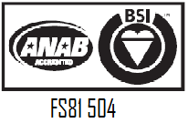
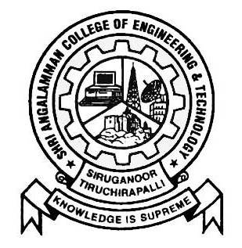
SHRI ANGALAMMAN COLLEGE OF ENGINEERING AND TECHNOLOGY
(An ISO 9001:2008 Certified Institution)
SIRUGANOOR, TIRUCHIRAPPALLI – 621 105

Non Teaching Staffs
S.No | Name | Designation | Qualification
1. | N.Tamilarasi | Lab Technician | D.E.C.E
2. | N.Jeeva | Attender

